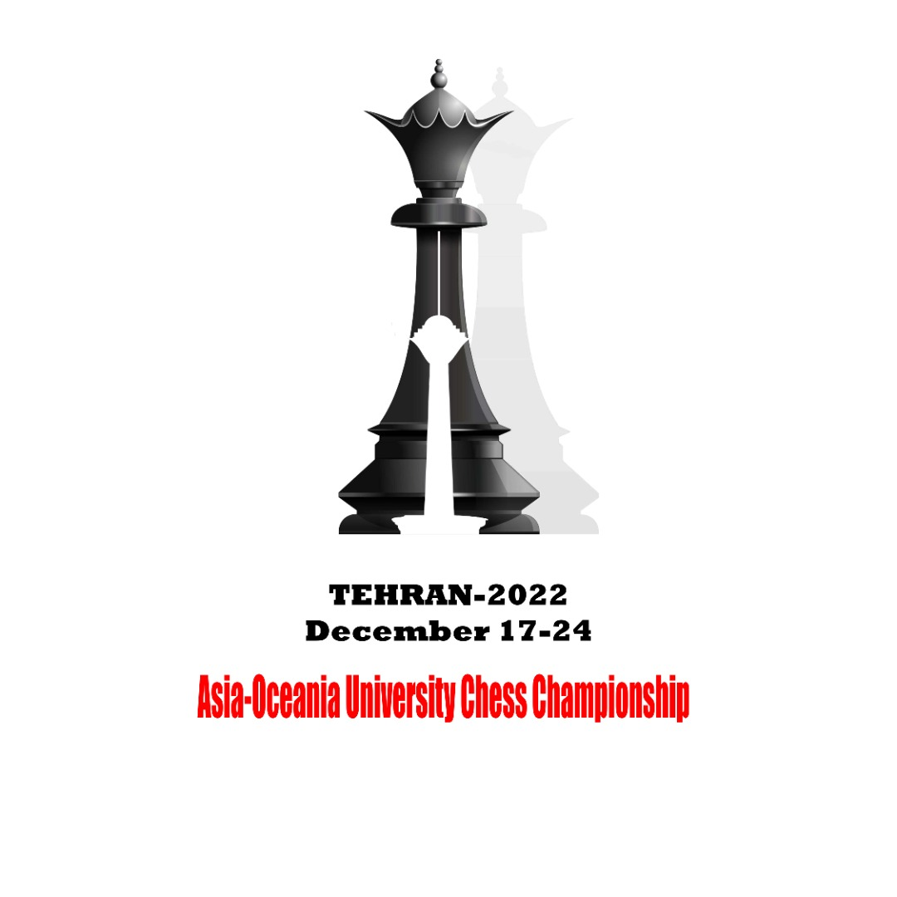 | 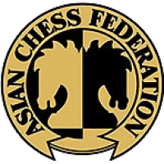 | 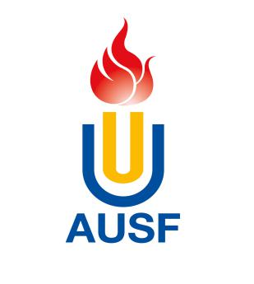

2022 Asia-Oceania University Chess Championship
Online, December 17th to 26th

OC Email: Irannusf@yahoo.com, Tel:+982188915251-3, Fax: +982188808732

Country/Region Country/Region Code

*National University Sports Federation – NUSF

Name of the NUSF
Address
City |  |  |  | Postal Code
Telephones | #1. |  | #2.
Tele fax |  | E-mail

Entry to be submitted to OC via email, and copied to AUSF no later than (dd/mm/yyyy) 17/9/2022

Name and Signature of the President or Secretary General of the NUSF

Seal

NUSF
Name | Function
Signature | Date

Entries arriving after the expiration of the required deadlines will not be taken into consideration, except in the case of circumstances outside one’s control, with the agreement of the Executive Committee and on the advice of the Organizing Committee.

Asian University Sports Federation
Bldg.33-2 Ronghuiyuan, Yuhua Rd., Shunyi district, Beijing, China,
Tel: +86 (10) 66093756, 66093764, Fax: +86 (10) 66093766,
E-mail: ausf@ausf.org; Website: http://www.ausf.org

